**TIMEKEEPER**

**Project Plan**

**&**

**Increment-1**

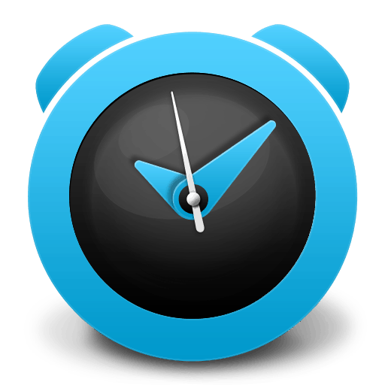

**Team – 3**

**♦ Srinivas Potluri (74)**

**♦ Swaroop Chitiprolu (15)**

**♦ Sesha Sai Prasanna Chennupati (13)**

**♦ Sampath Boddeti (6)**

**1. Introduction**

**TimeKeeper:**

In the present world, Health and Time are the two most important aspects in everyone’s life. So, this application comes with a reminder and alarm for different types of purposes which will be explained in the further proceedings.

**2. Objectives and Project goal (Revised)**

**2.1 Goal**

The foremost objective of this application is to keep a person up to date with the things that he/she needs to do on a specific date and on a specific time and to make him/her punctual at their work and things that need to be done.

**2.2 Specific Objectives**

2.2.1 Notifying the users about the things such as Assignments, Taking Medicines, Shopping.

2.2.2 Waking the user using an alarm

2.2.3 Capable of storing notes that are important to the user

**2.3 Specific Features**

2.3.1 The Application uses Voice to remind the things that need to be done.

2.3.2 The Application uses the Google Maps API to notify the destination and the things nearby in the path of your travel.

2.3.3 The Application uses various types of games to wake up the user.

**2.4 Significance**

The Application provides a combination of reminder, wake up alarm and Notes for the user without using different applications.

**3. Project Plan**

**Zen-Hub Screenshot:**

**Issues:**

We had the issues regarding

Creating Logo & Title, Designing UML and Class Diagrams, Designing Wireframe Diagrams, Login and Registration Pages, Home Page, Running the Application in Mobile, Preparing Documentation.

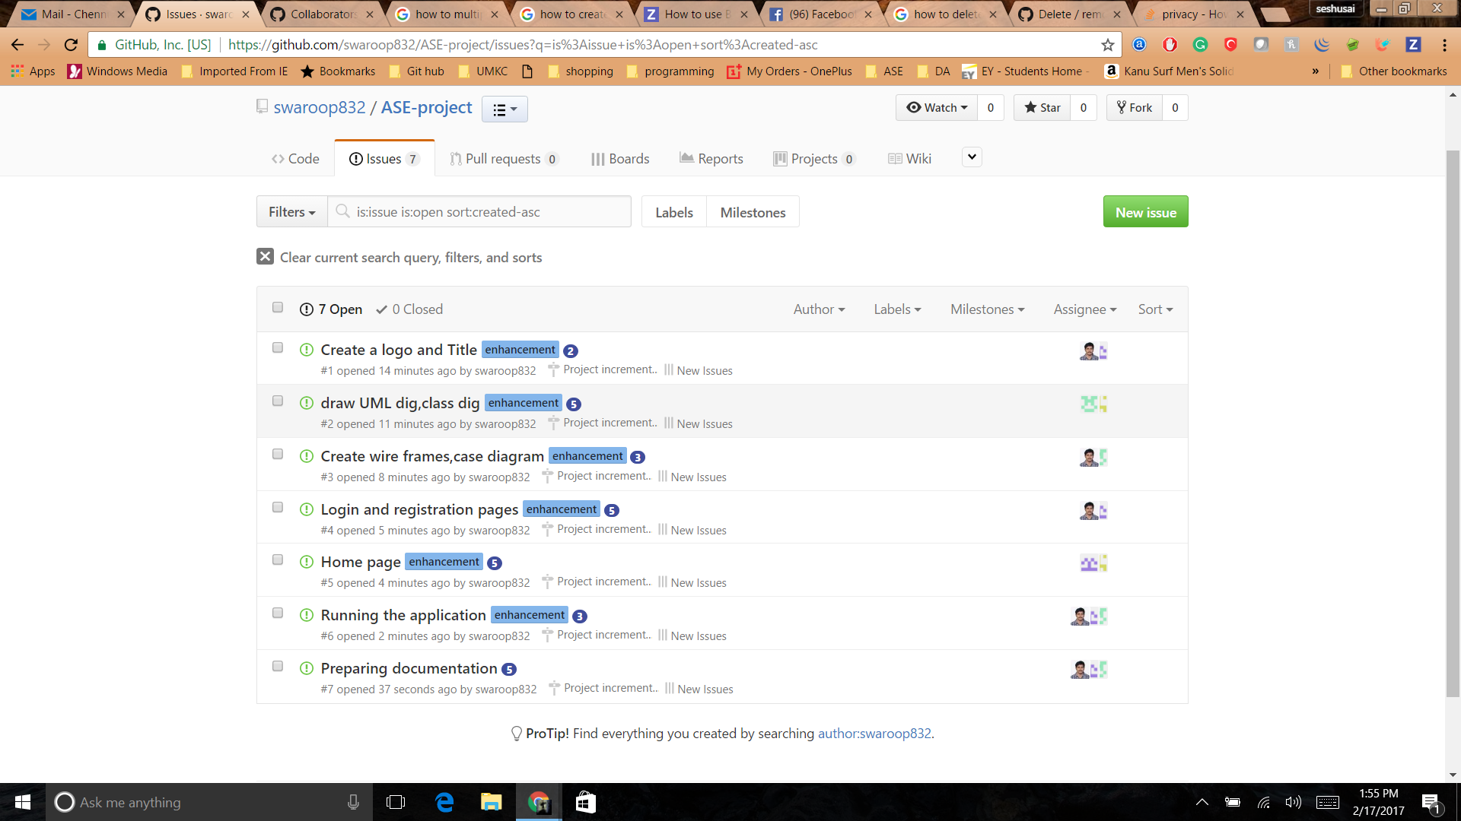

**Project Timeline, Members, Task Performed**

The below screenshot gives an idea regarding the issues and state of the issues.

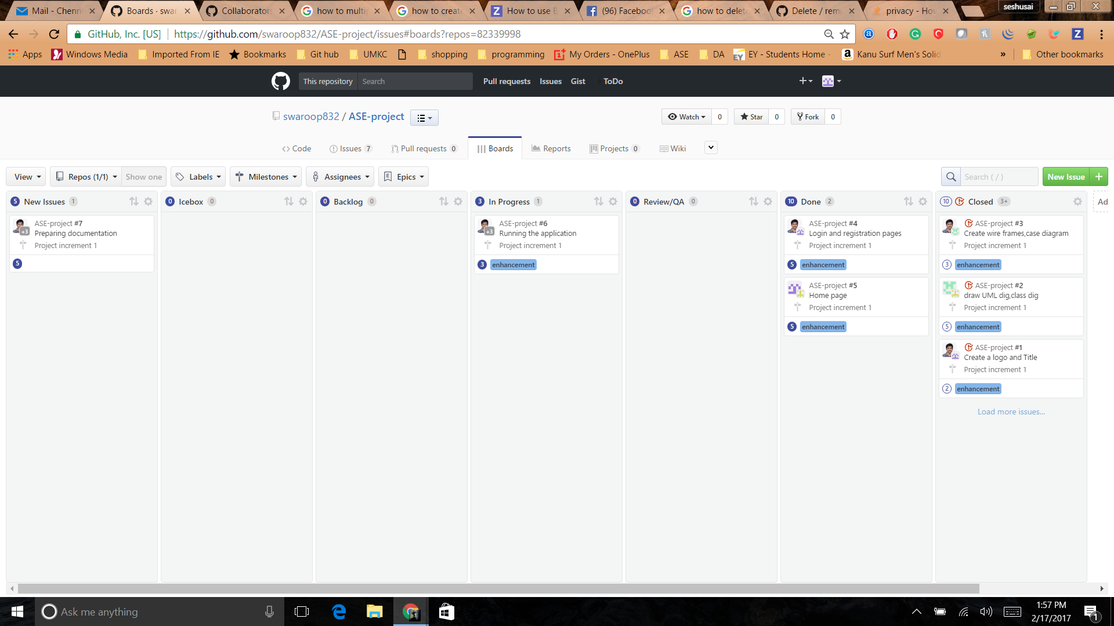

**Burn-Down Chart:**

The Burn-Down chart was created based on issues that we faced.

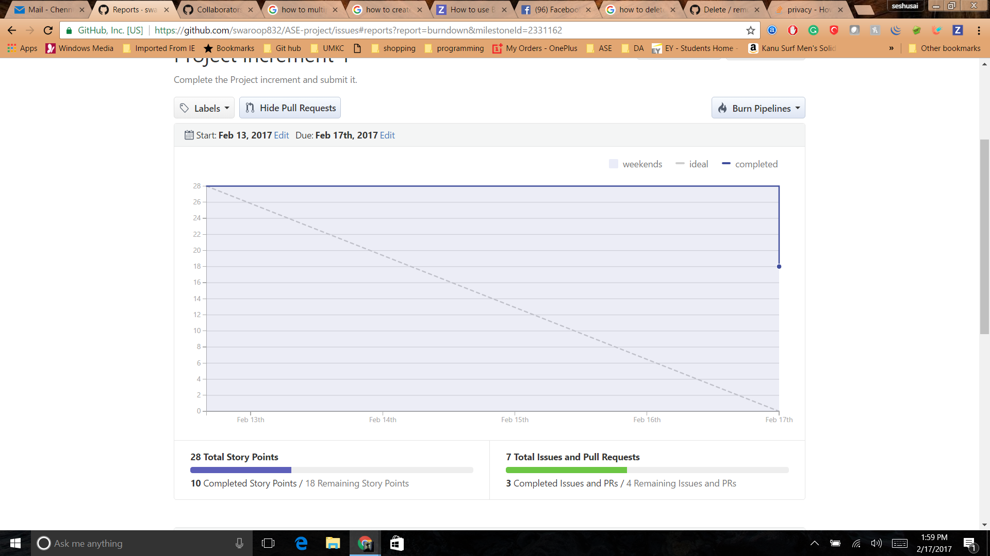

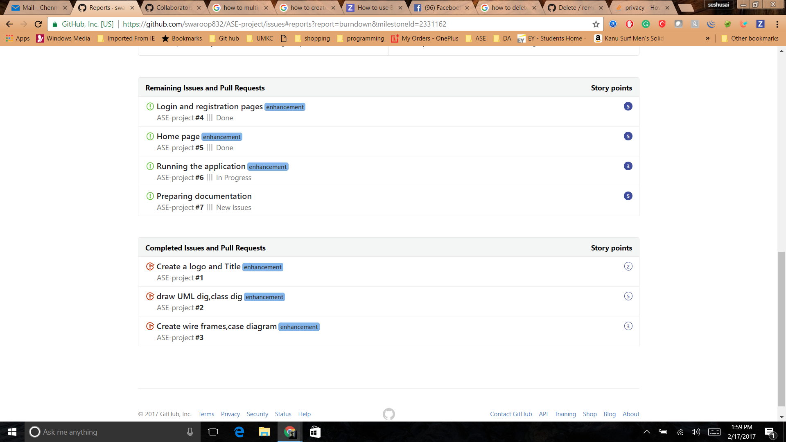

**4. 1st Increment Report**

**4.1 Services/API**

**4.1.1 API’s we Used**

**4.1.1.1 Facebook API:**

We did integrate Facebook API to the application.

We shall use below mentioned API’s in the upcoming increments to implement the technologies.

• We shall also use Google Maps API and Calendar API

**4.2 Design of Features in detail:**

**Wireframes**

1. **Login Page (wireframe):**

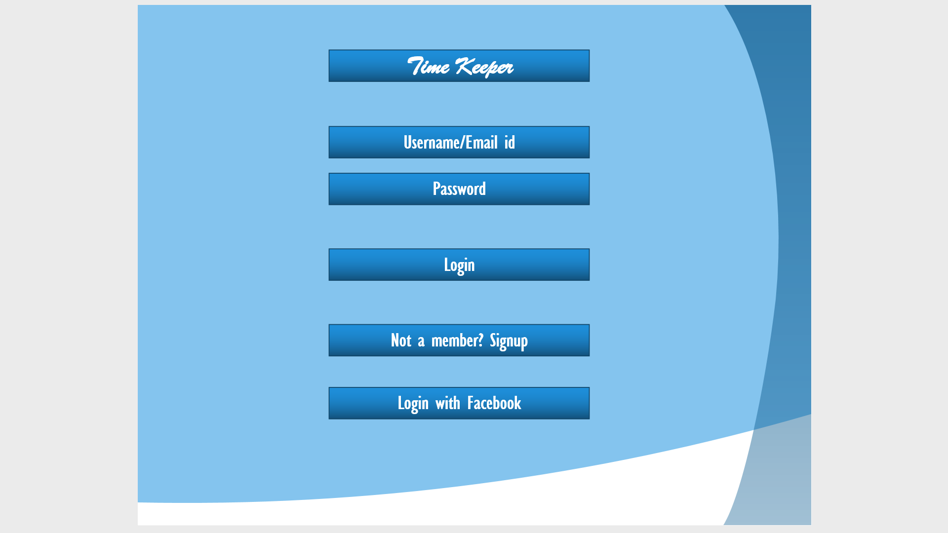

1. **Register Page (wireframe):**

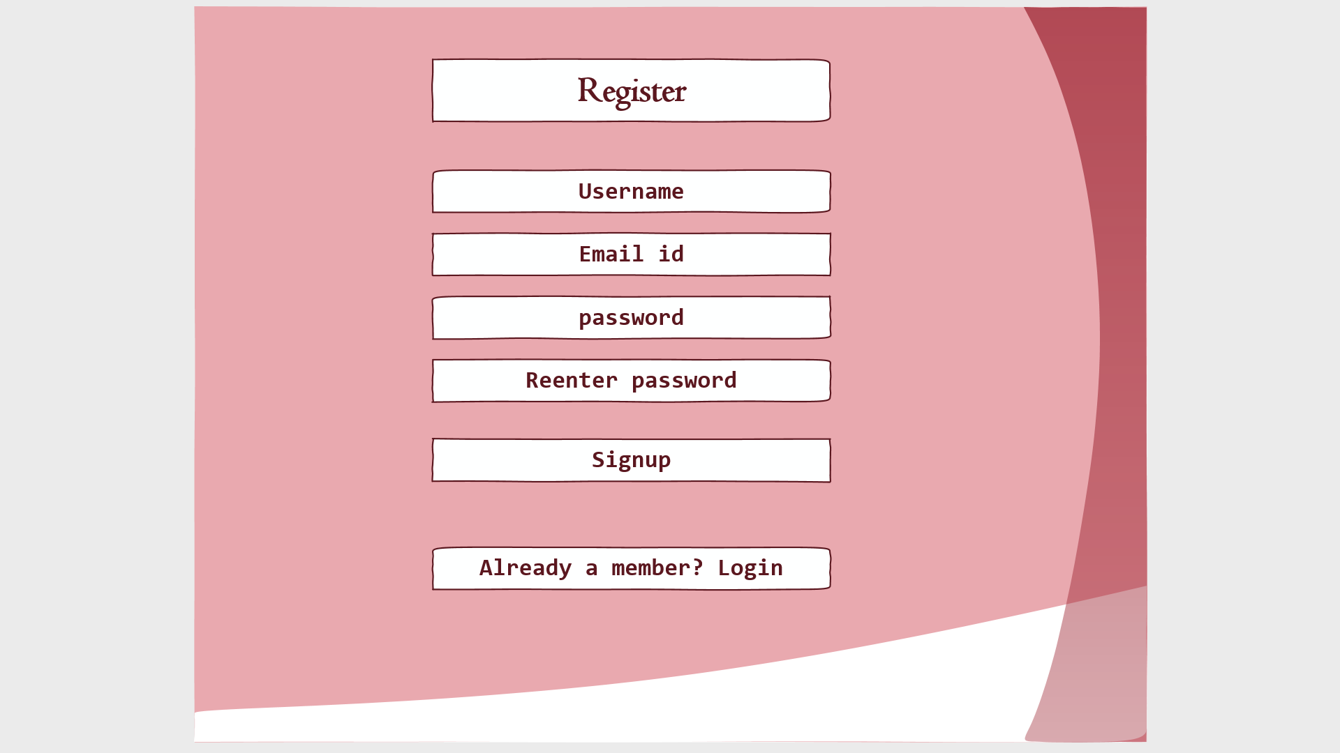

1. **Home Page (wireframe):**

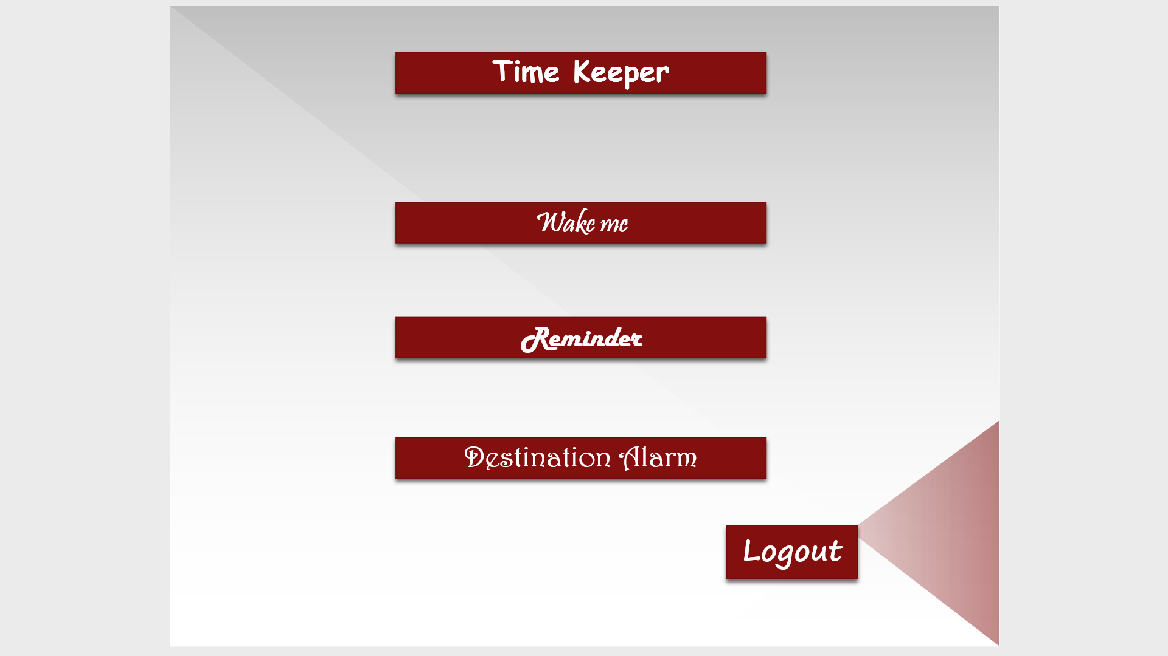

**Class Diagram:**

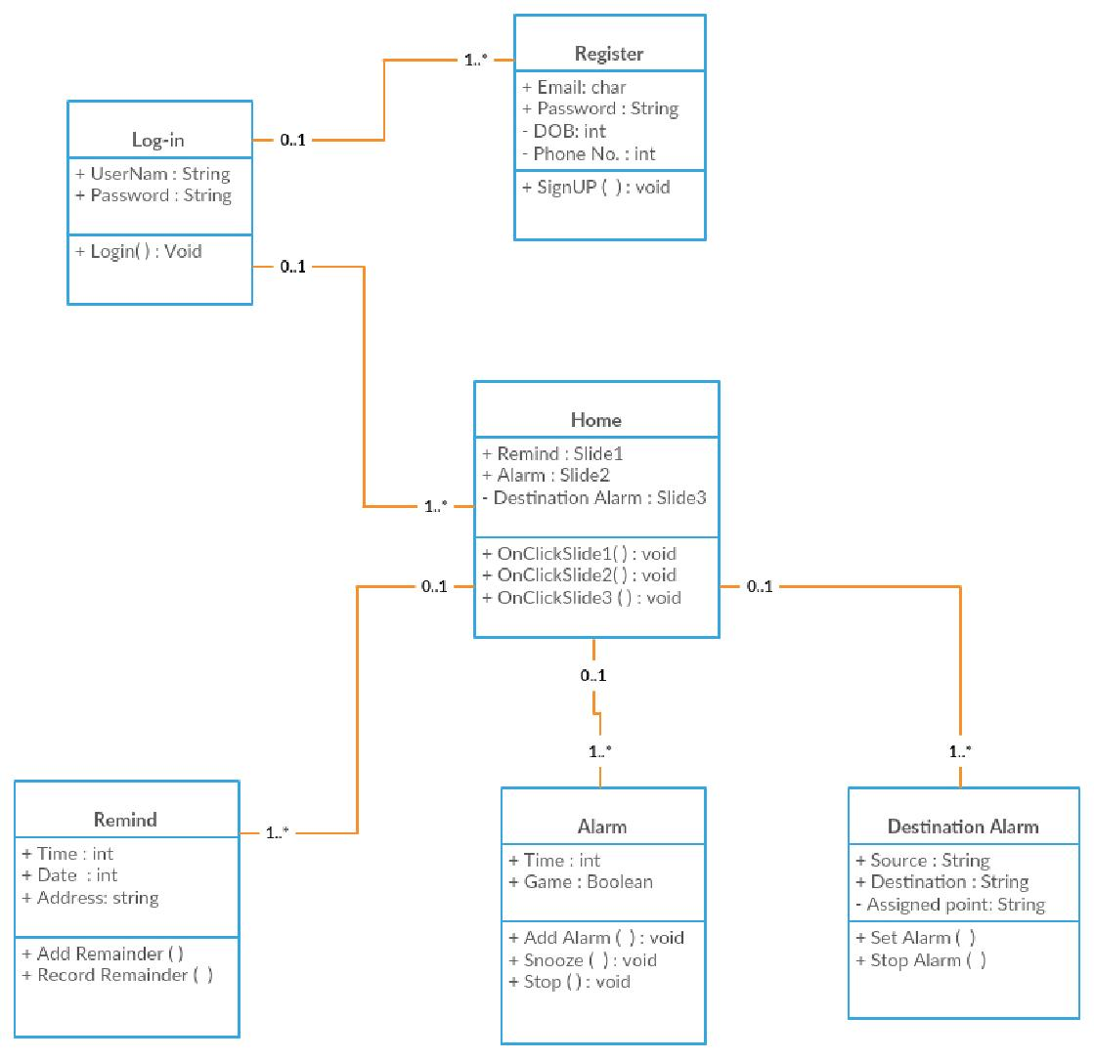

**Case Diagram:**

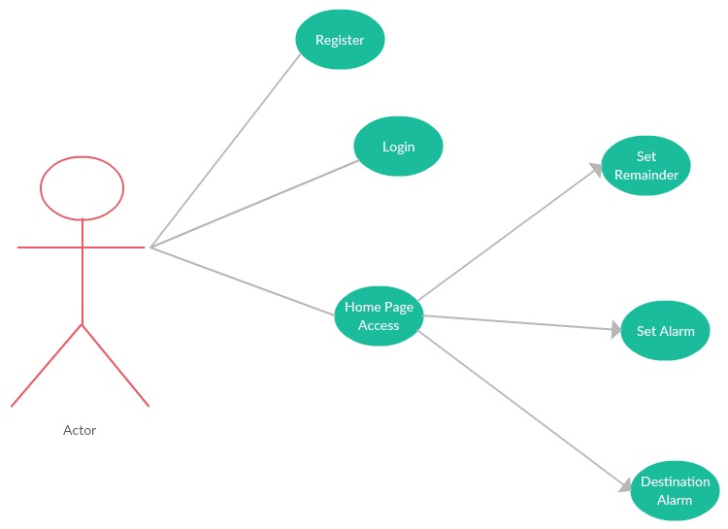

**Sequence Dig:**

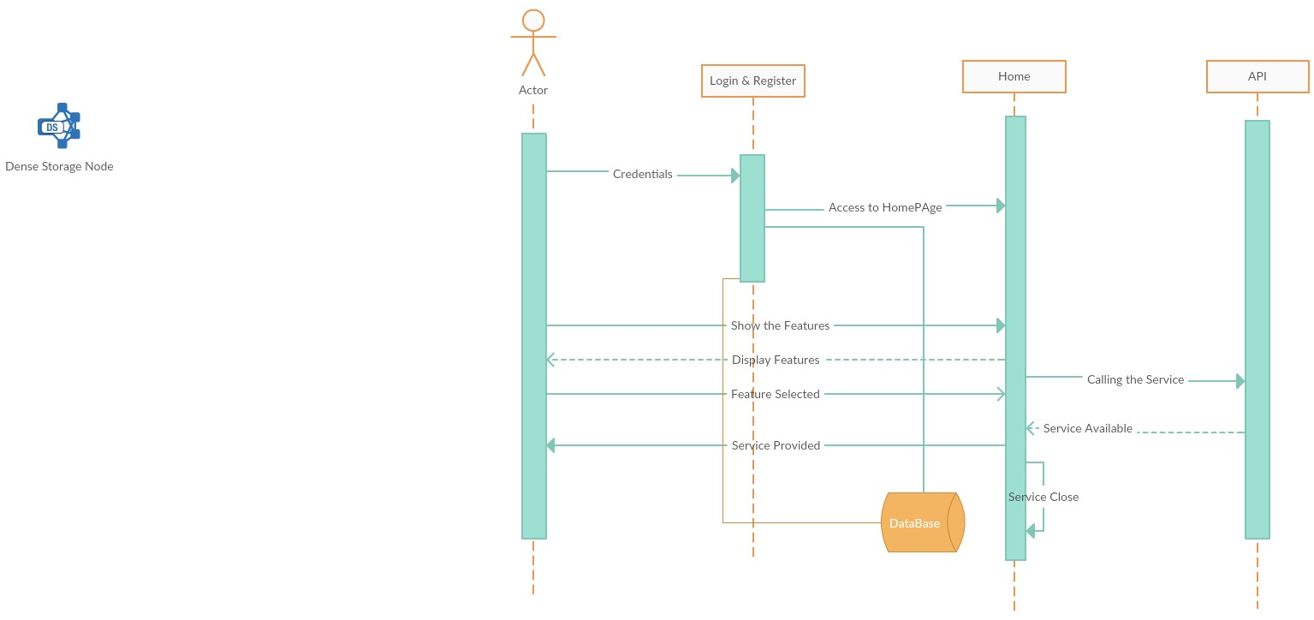

**Architecture:**

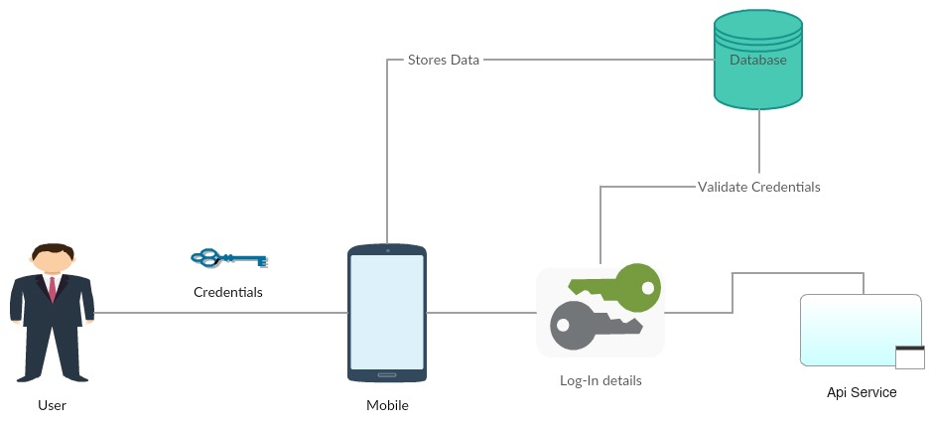

**User Stories:**

|  |  |  |
| --- | --- | --- |
| **I am a** | **My Purpose.** | **Benefit** |
| **User.** | **Remind**  Set Remainder | Notifies the activities. |
| **Wake**  Set Alarm | Wakes me up with a interesting puzzle. |
| **Notes**  To store some quotes and make Notes which are important | Helps in storing data in the way of taking notes and some might have a habit of writing dairy, so they can use this. |

**Testing**

**Cases for Register and Login Pages:**

|  |  |  |  |
| --- | --- | --- | --- |
| **Cases** | **Description for Test case** | **Results Expected** | **Genuine Result** |
| Login | Please enter Invalid Username & Password | It is Error | It is Success |
| Login | Please enter Invalid Username & Valid Password | It is Error | It is Success |
| Login | Please enter Valid Username & Invalid Password | It is Error | It is Success |
| Login | Enter Valid Username & Valid Password | Logged into Home Page | It is Success |
| SignUp | Email ID should end with @mail.com | Invalid Mail | It is Success |
| SignUp | Length of Password should have minimum 8 characters | Password Weak | It is Success |
| SignUp | Password column and Confirm Password column should match | Registers shall be Directed to Login Page | It is Success |

**5. Project Implementation**

We implemented the TimeKeeper App in Android Studio and run it on the Android device. Screen shots shows how the application is run.

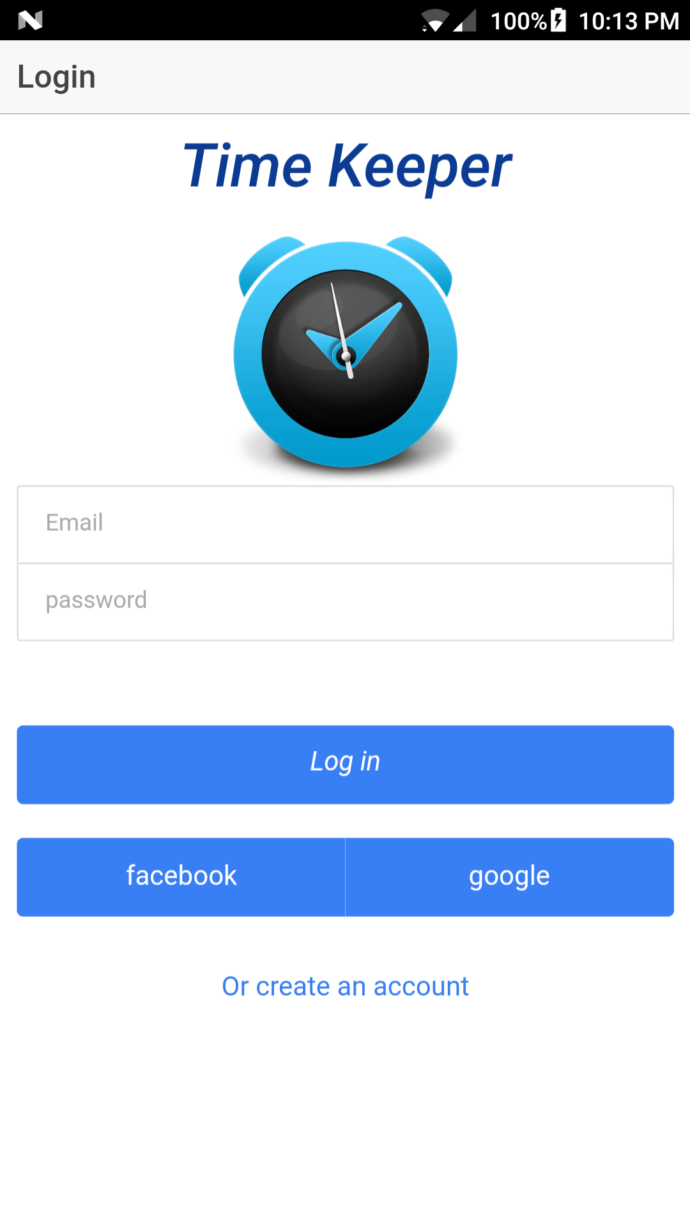

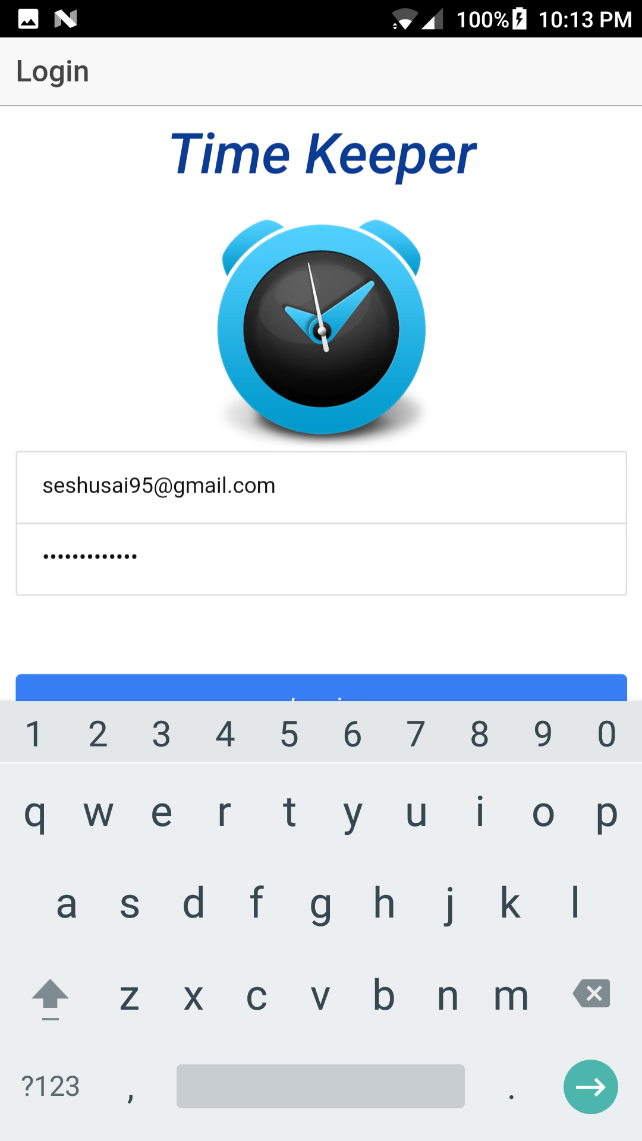

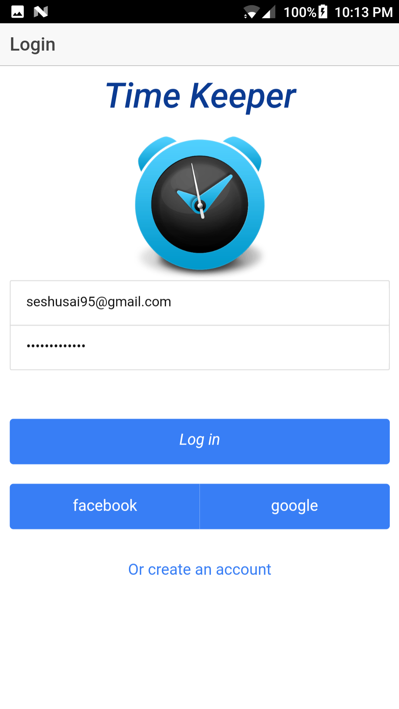

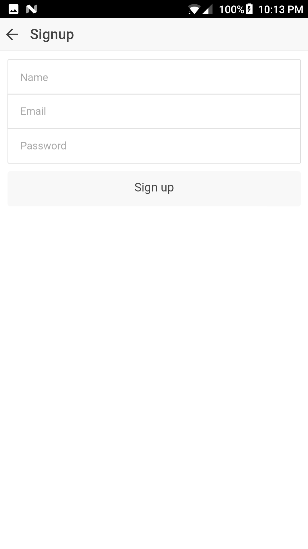

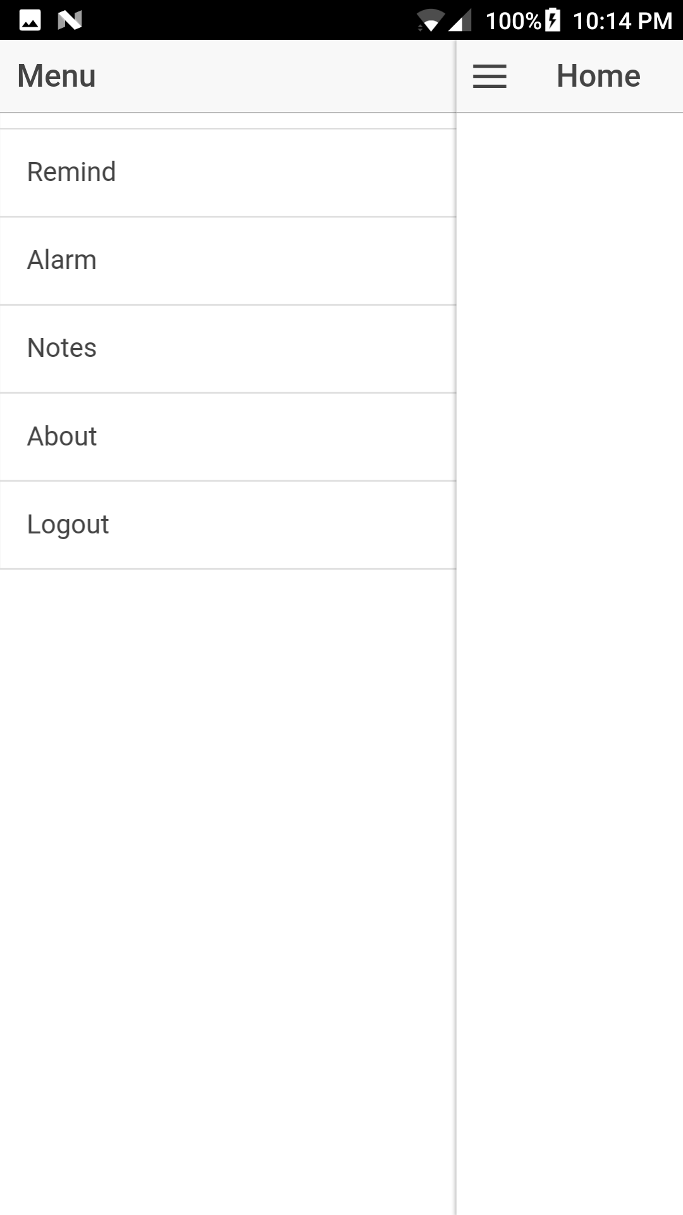

**Project Plan**

**Increment-2**

**Project Timeline, Members, Task Performed**

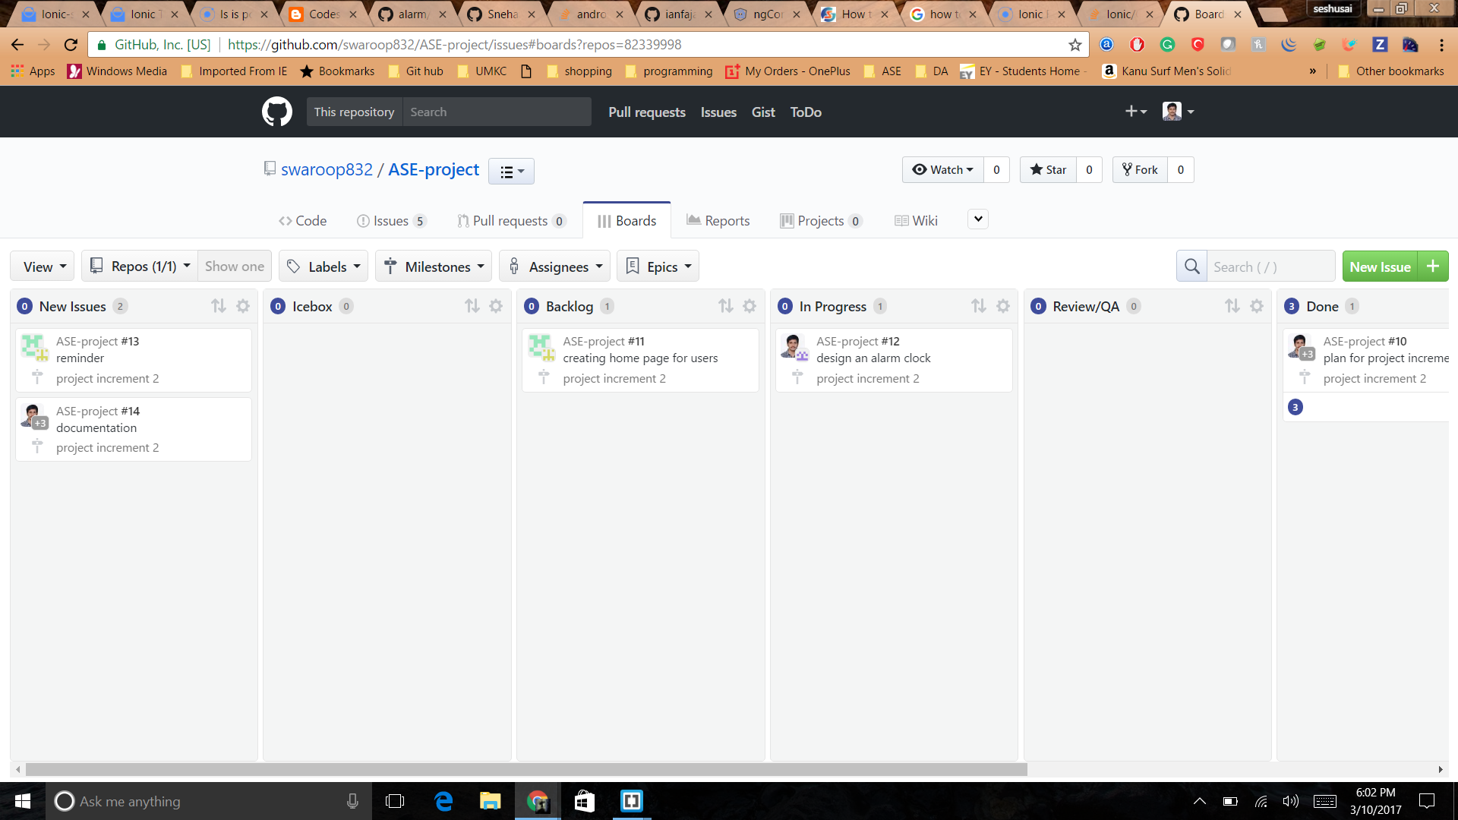

**Issues:**

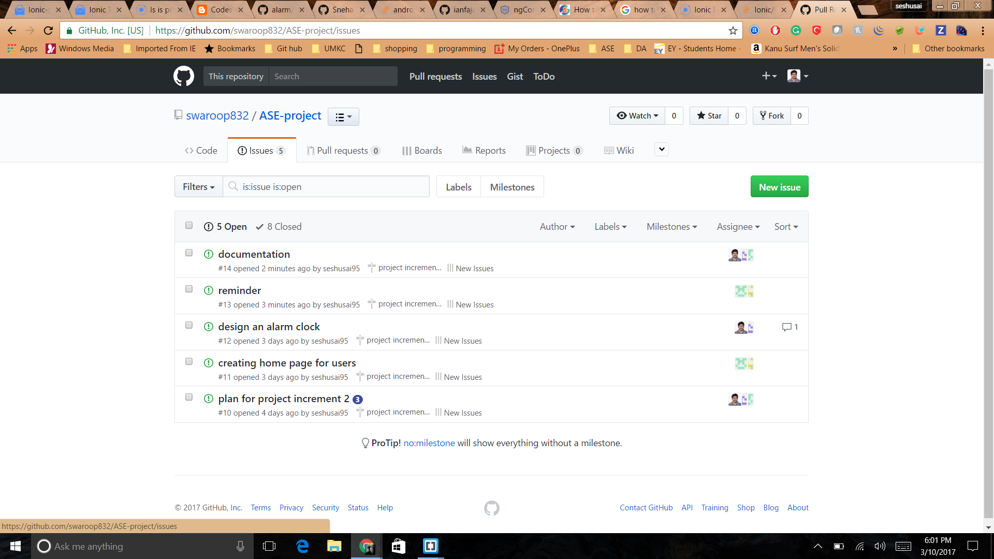

**Burn-Down Chart**

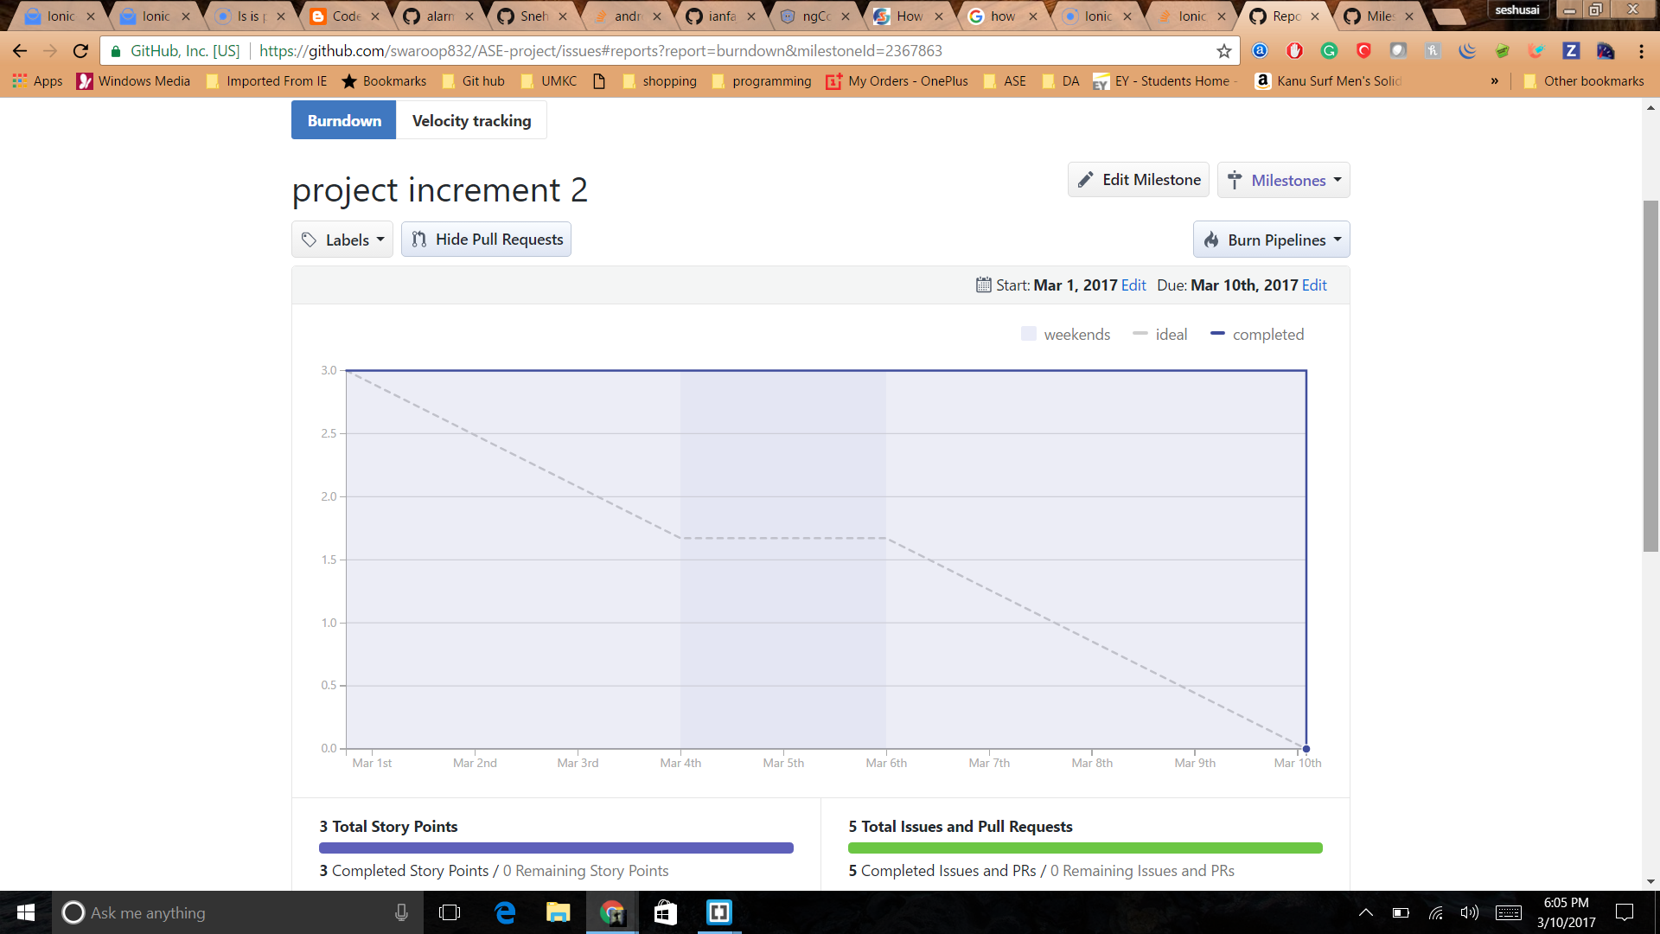

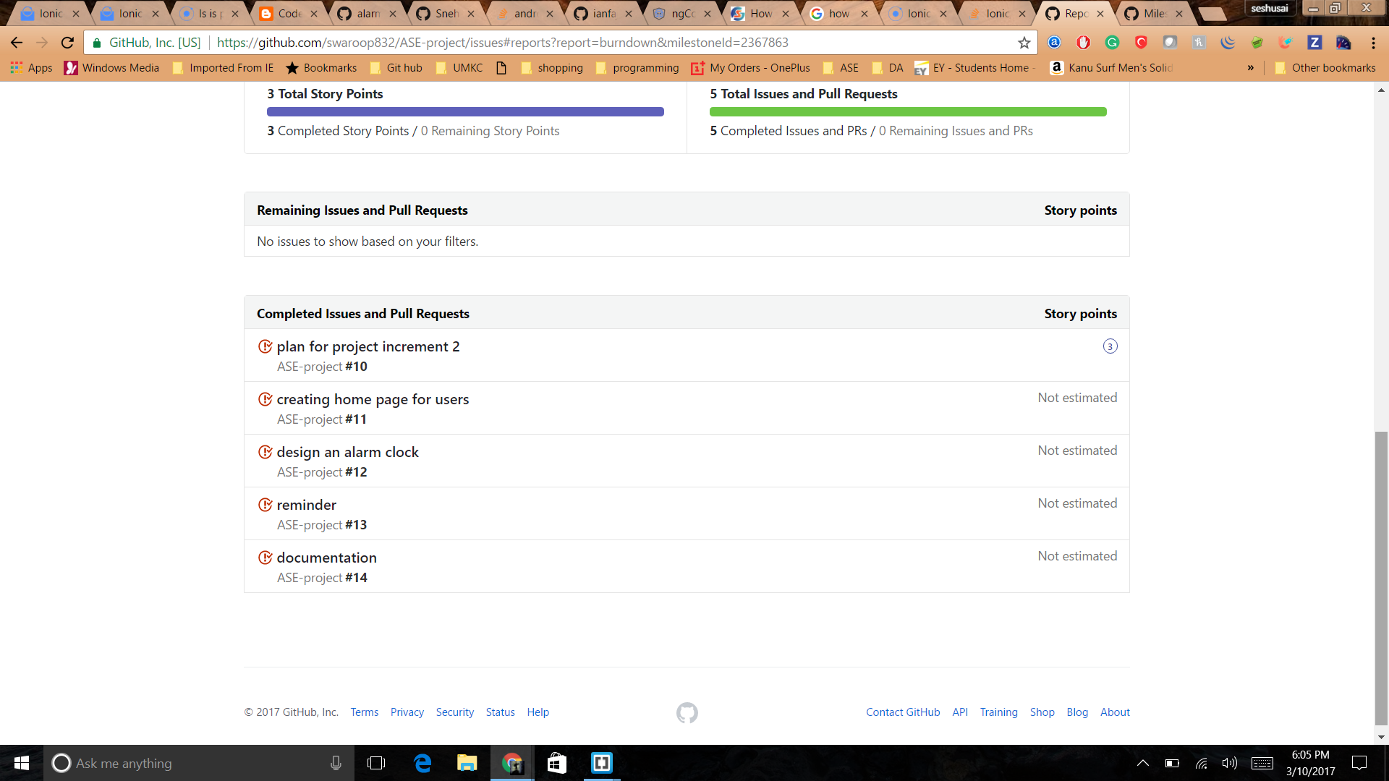

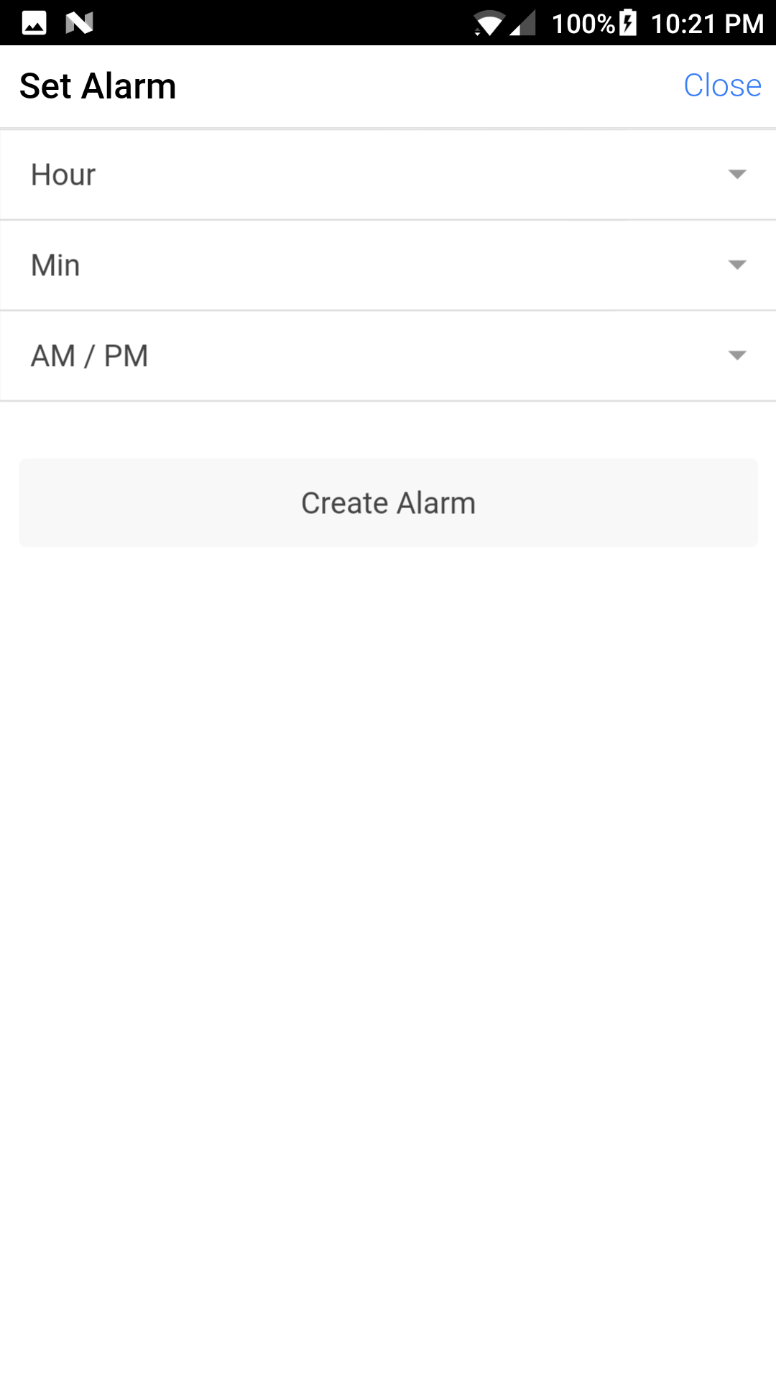

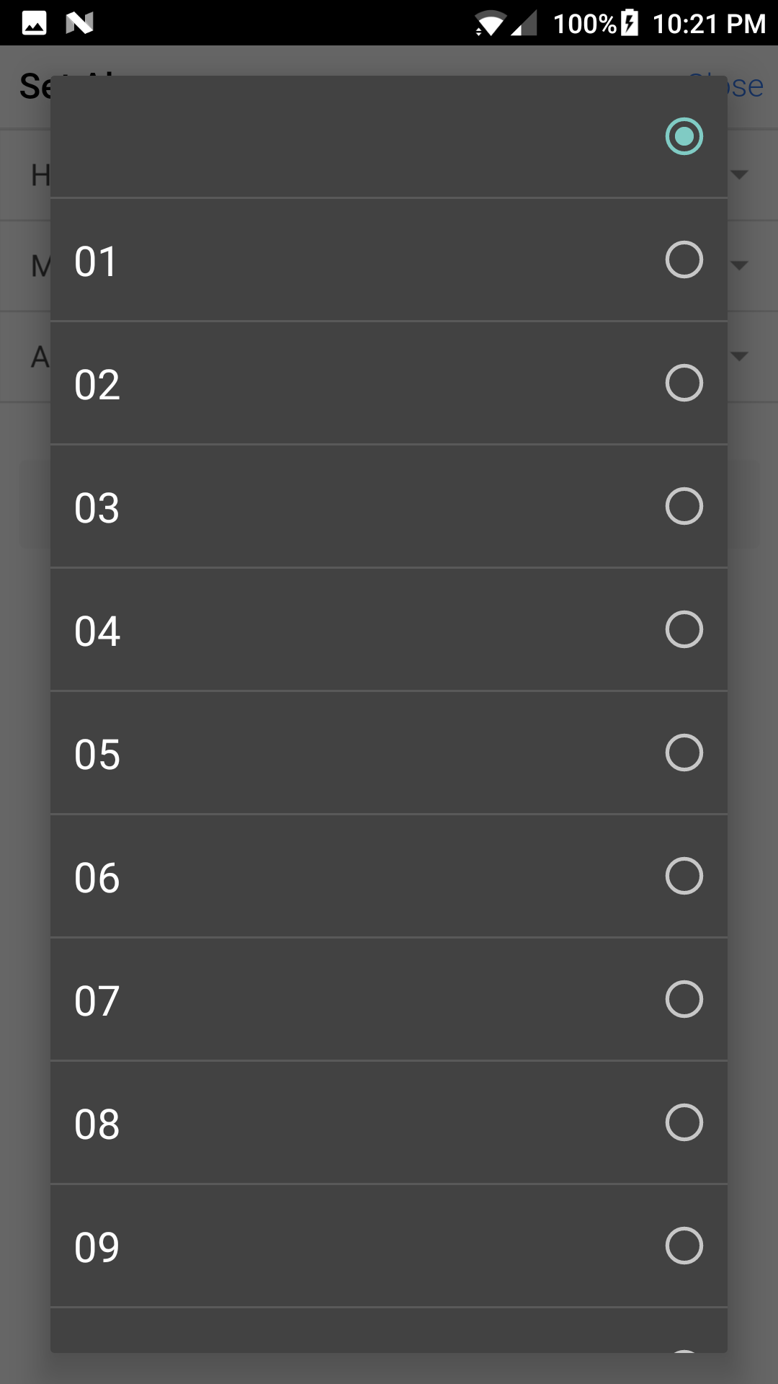

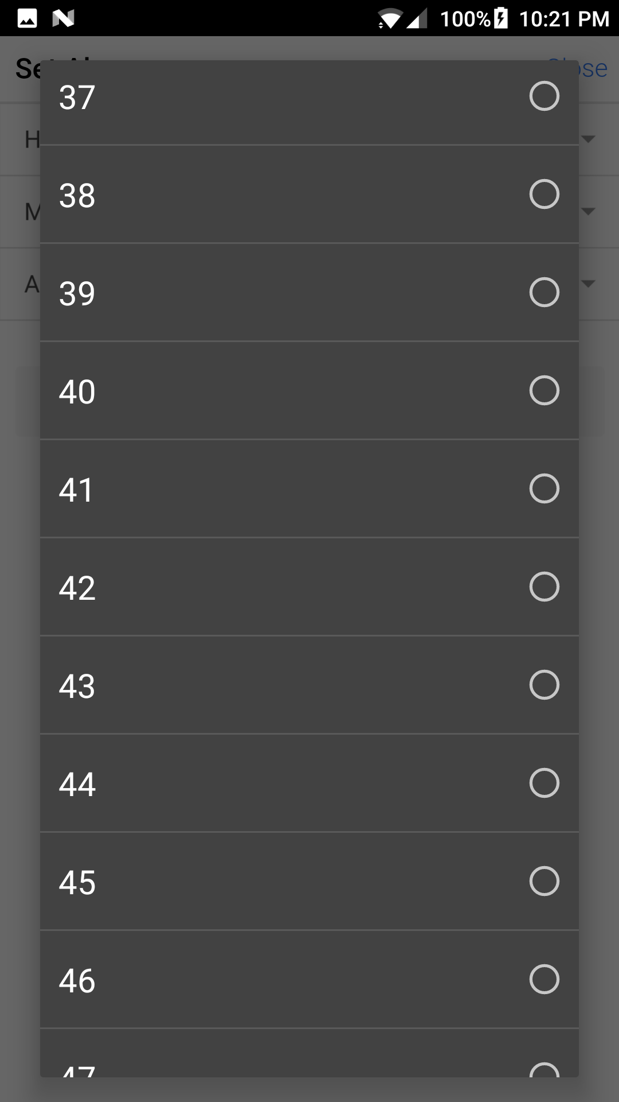

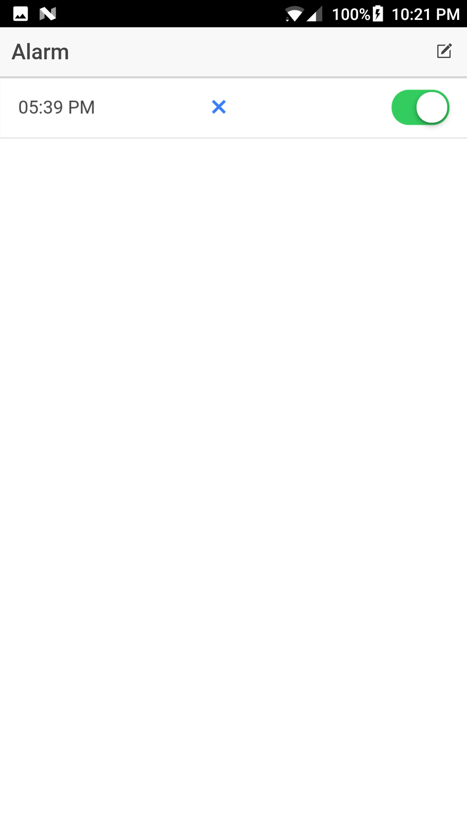

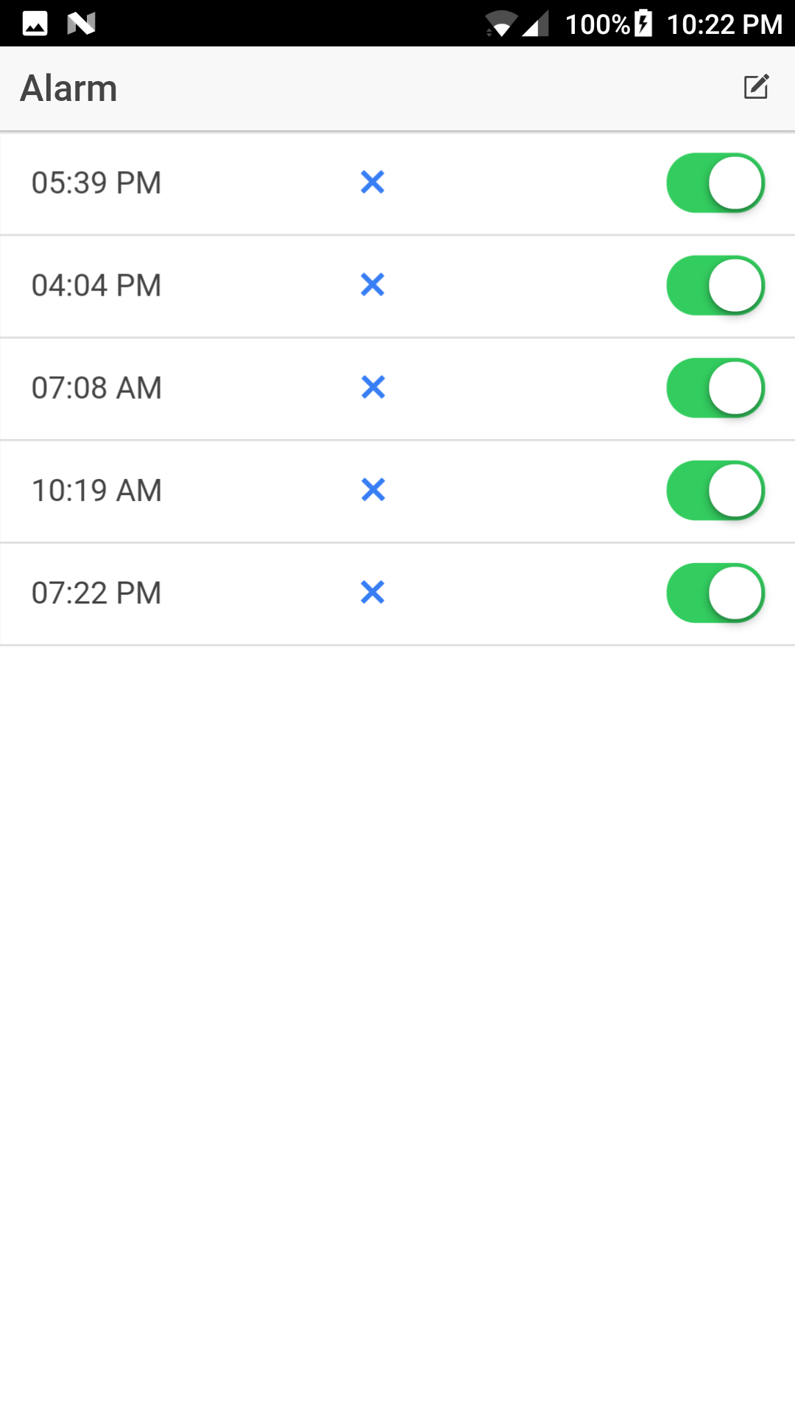

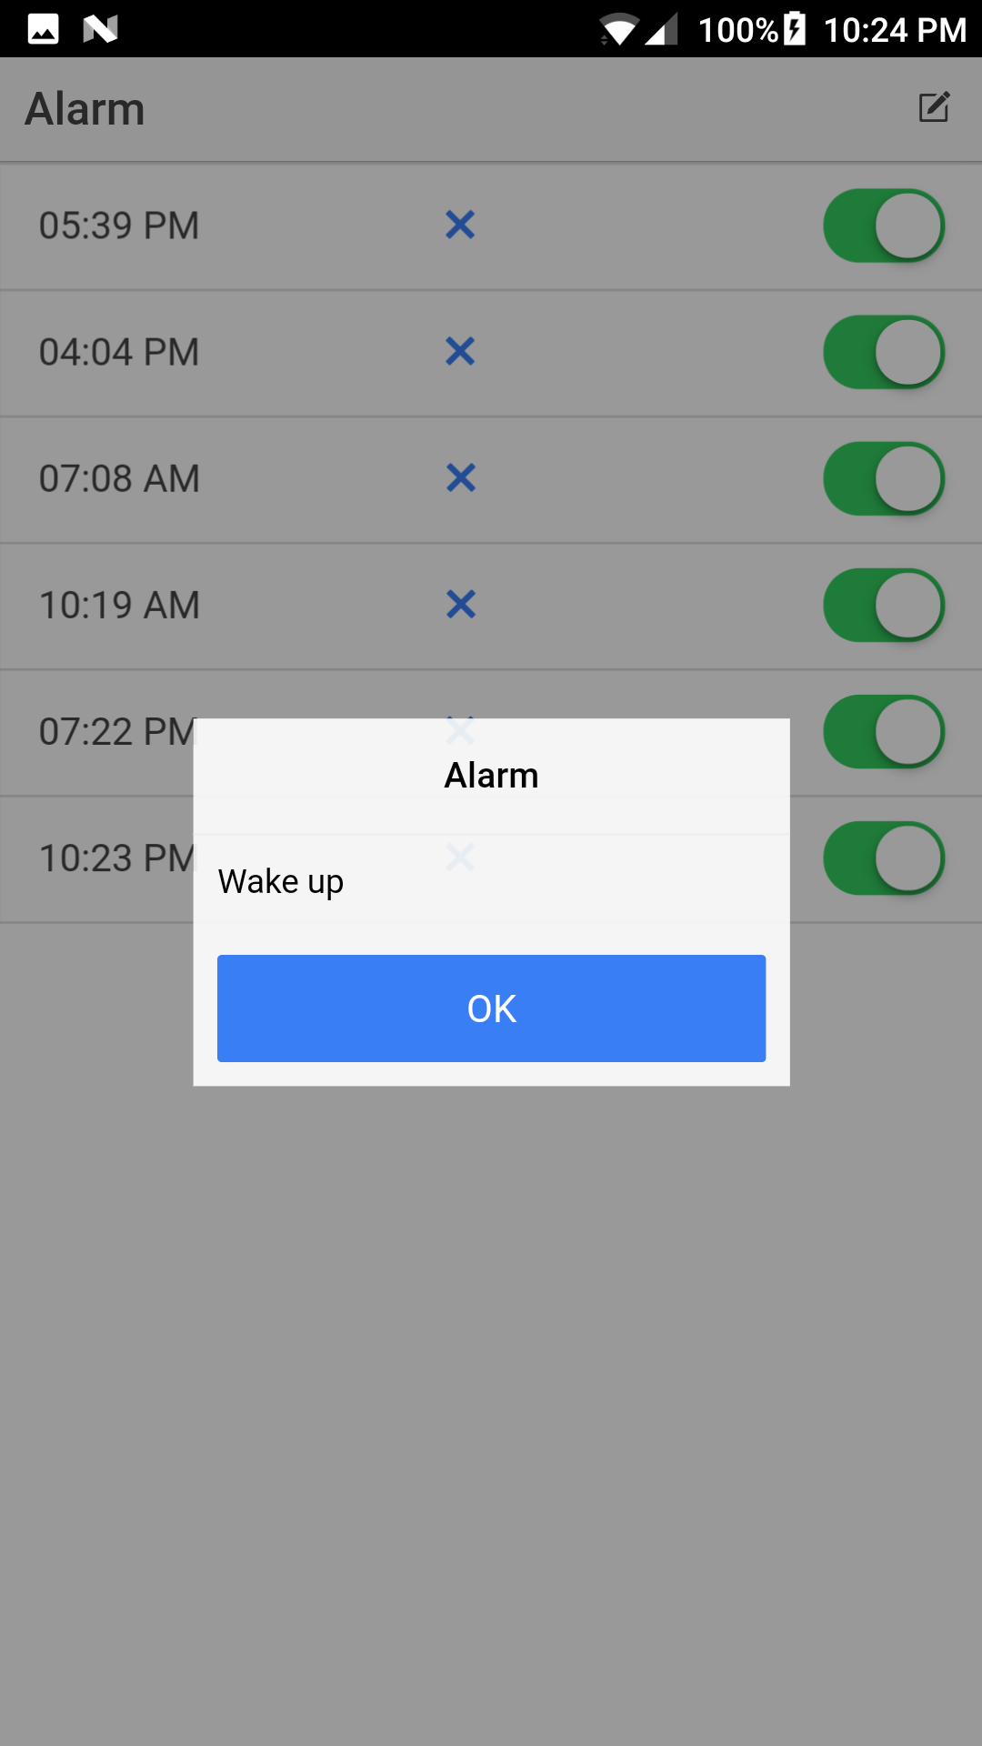

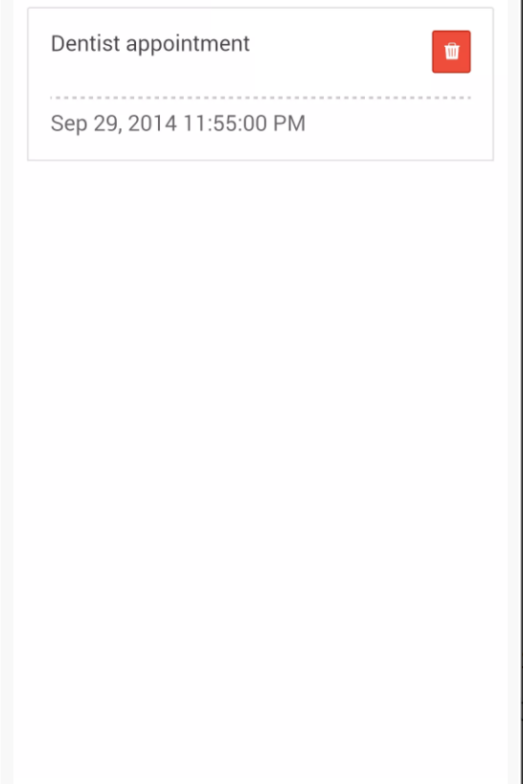

**Implementation status report**

**Technologies Used:** Android SDK, HTML, CSS, JS, Angular JS, J2EE.

**Work Completed**

• Design and Architecture of the Application

• Login and Registration using Android

• Implemented Alarm

• Implemented the application in Ionic platform

• Started working on Reminder page

**Work to be Completed**

• Improving the User Interface of the application.

• Collecting the API useful for the application.

• Should work on Reminder page and Notes page

• Improving User Interface of Alarm Page and enabling text to speech

**GitHub URL**: <https://github.com/swaroop832/ASE-project>

**Wiki Page:**

**Project Management**

**Technologies we Used:** Ionic Framework, HTML, CSS, JS, Angular JS.

**Contributors:**

• Srinivas Potluri – 25%

• Swaroop Chitiprolu– 25%

• Seshu Sai Prasanna Chennupati – 25%

• Sampath Boddeti – 25%

**7.Bibliography**

1.<http://creately.com/>

2.<http://developers.facebook.com/>